Epitaph Poetry
An Epitaph is a brief poem inscribed on a tombstone praising the life of a deceased person usually with rhyming lines.
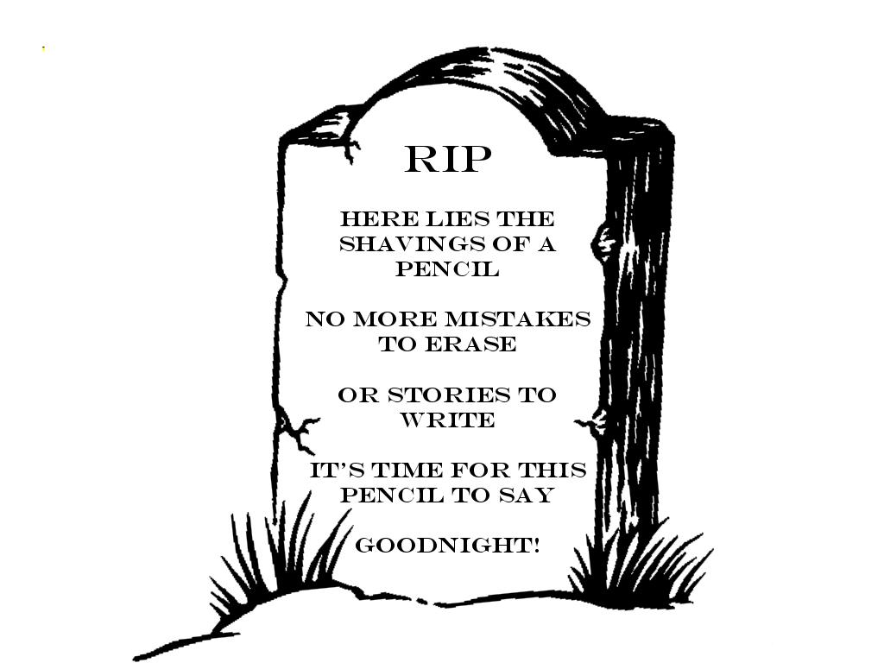
Take some time to think about something you use all the time. It could be a computer, a toaster, or an electric toothbrush.....the choice is yours.

MONSTER POEM:
Describe an imaginary monster. Try to have a theme (food, sports, animals, school subjects etc.)
An example is-
"The Scrumptious Sweet- Tooth Monster"
The Scrumptious Sweet- Tooth Monster has:
Hershey Kiss Cranium
Peppermint Smirk
Appealing Rock Candy Torso
Red Licorice limbs
Black Licorice appendages
Green and Blue M&M eyes
Bubble gum feet that blow up into hefty bubbles when he scampers
Snout is made of a bulky scoop of rocky road ice cream that is so cold it will never liquefy
Vibrant Colored Chiclets for his choppers
Tootsie Rolls for eyebrows
In a crown form he has Sweet Tarts for locks of hair
Left Fingers are made of grape lollipops
Right Fingers are made of Watermelon lollipops
this is one appetizing monster!

